**Input-Output and File Handling**

<https://docs.google.com/document/d/1NQRyQJuwIi1jBoN2HhG0m_xGh-2m4n64-BMIKRXspZ8/edit?tab=t.0>

Q1)You have a number.txt, with each line a real number. Write a code to split this file into 3 files as follows: even.txt -- contain all even numbers odd.txt -- all odd number float.txt -- all floating point number Use with() clause for file handlong

Created numbers.txt file with a few odd even and float values, wrote a match case statement where if the encountered number when divided with 2 gives remainder 1 its added to odd.txt, remainder 0 its added to even.txt and otherwise it goes to default case “_” where its added to floats.txt. Used shell to demonstrate this problem solution with ls and cat commands

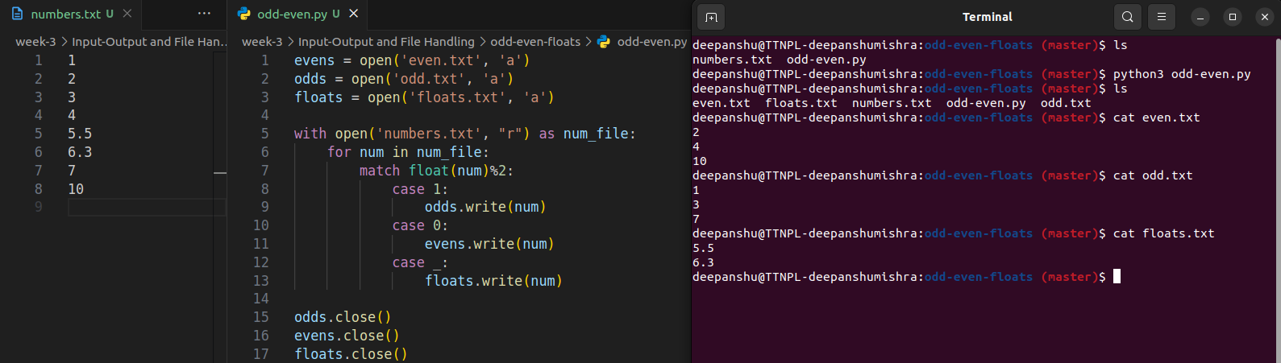

Q2)Write a code to read a "Python_script.py" as inpit file and extract following information to prepare a JSON

* all package name which the input Python script use

* all function name which the input Python script define

* all class name which the input Python script define

* all the variable name which the input Python script define

Note: cant seem to get the functions part working

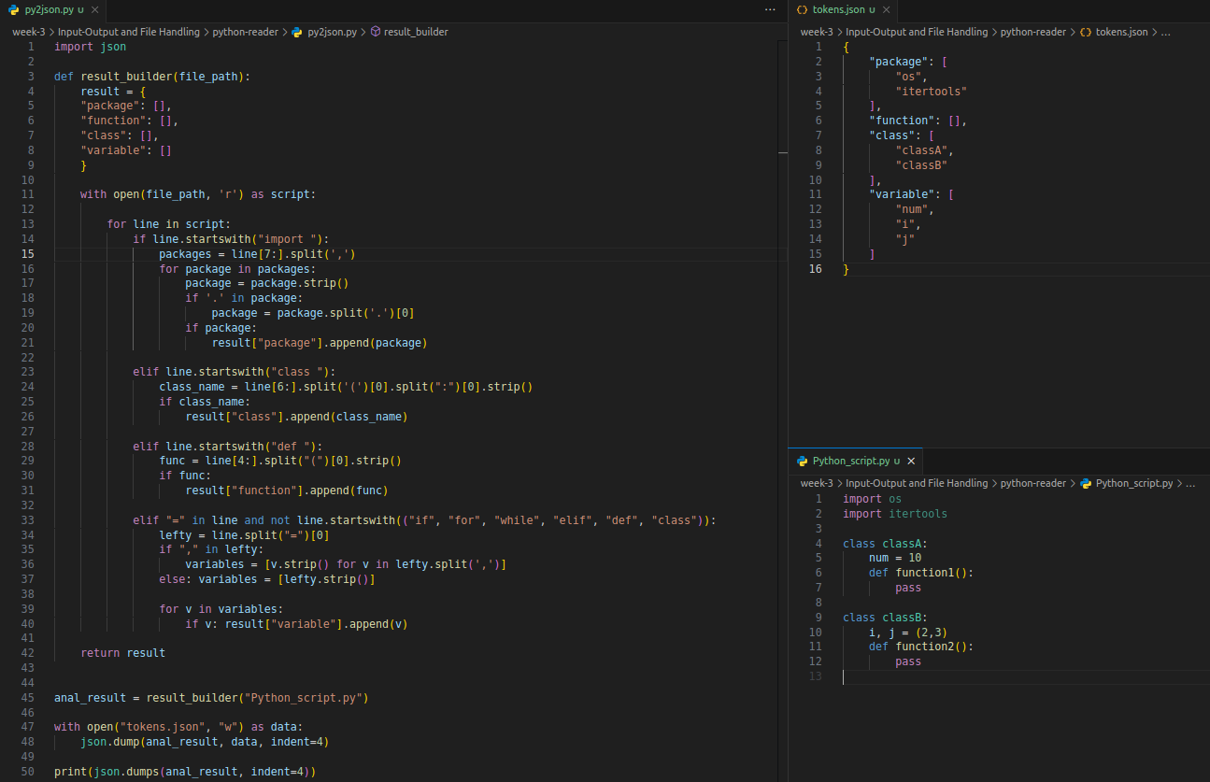

Without using Python CSV module write a "csvlook` command

csvlook should have following features:

* [-d DELIMITER] if -`d` option not paased script should be able to guess a seperator

Delimiter guess function

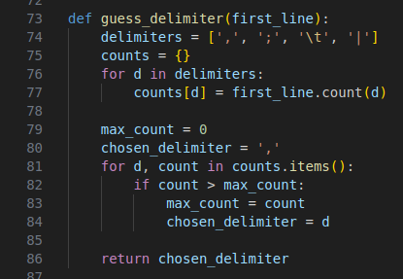

* [-q QUOTECHAR] used to parsed colum value parenthesised within QUOTECHAR, if the value not passed should assume default value dboult quote

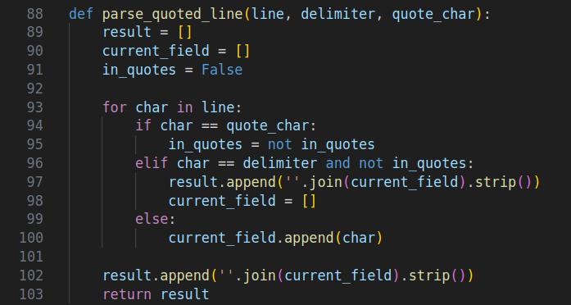

`csvlook` should display data nicely on console in uniform width

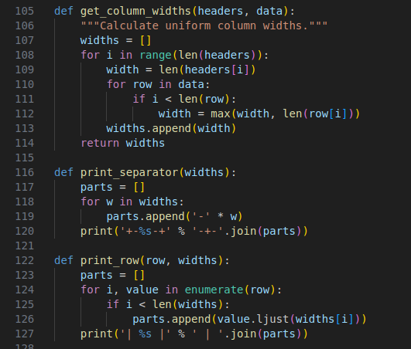

To project the data `csvlook` script should accept comma seprated colum numbers, e.g

-f 3,5,7 should print only column 3, 5 7

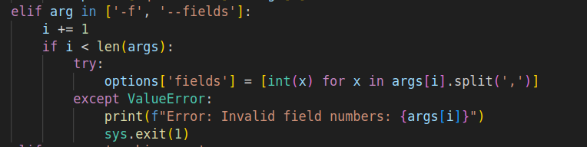

--skip-row N to skil first N rows

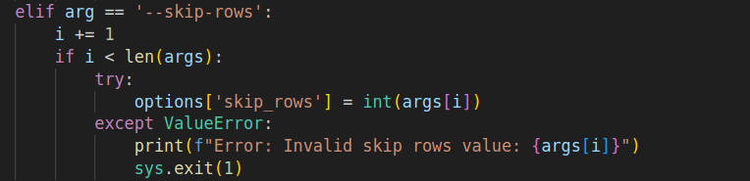

--head N to display only first N rows

--tail N to display last N rows

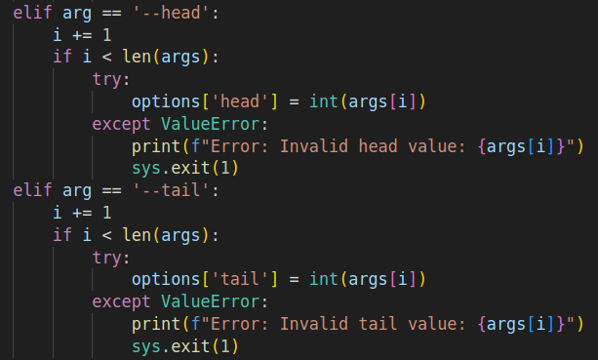

Argument parsing function: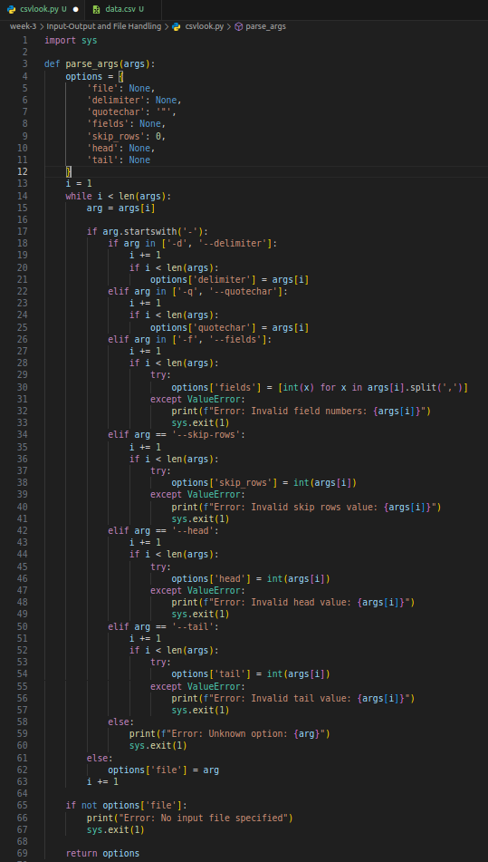

Output generator function  
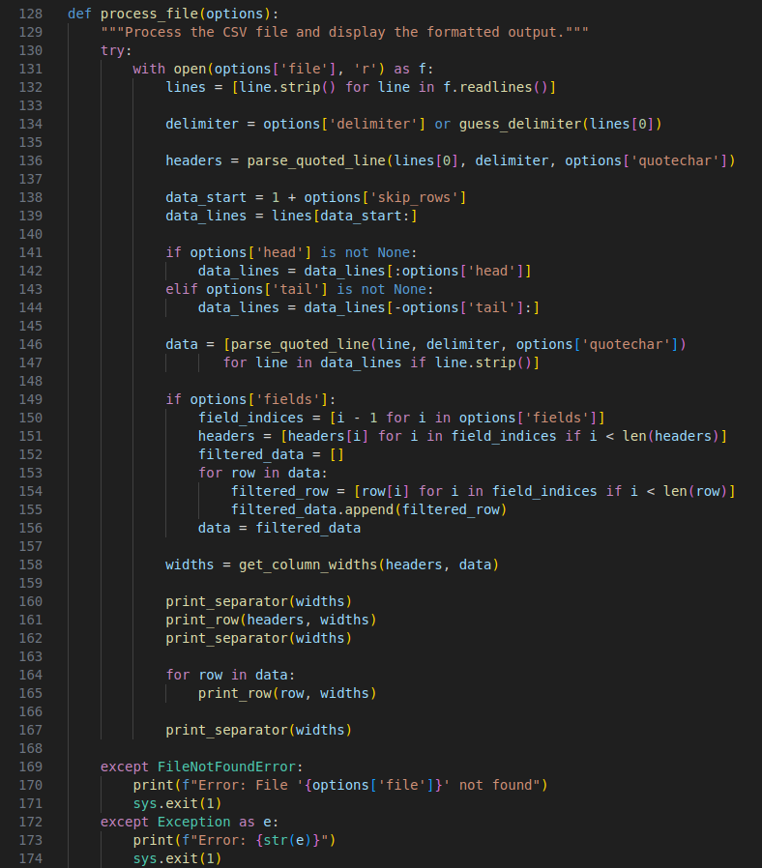

usage:

